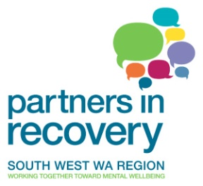

**What is Partners in Recovery?**

Partners in Recovery (PIR) is a Commonwealth funded mental health initiative that aims to better support people with **severe and persistent mental illness with complex needs, and their carers and families**. A coordinated and integrated approach is used to ensure that PIR consumers receive the best possible services and supports.

PIR objectives include;

* Facilitating improved coordination and collaboration of community services to deliver 'wrap around' care
* Strengthening partnerships in delivering services to the PIR target group
* Improving referral pathways for the PIR target group, and
* Promoting a community based recovery model to underpin community services for the PIR target group.

The focus of the transition phase of the PIR Program is to support the National Disability Insurance Scheme (NDIS) rollout. PIR organisations will ensure service continuity for existing clients and:

* Assist PIR clients to test their eligibility for NDIS supports;
* Assist eligible clients to access NDIS supports; and
* Provide PIR services to NDIS participants during the transition phase.

**Who is eligible?**

Individuals that meet the following eligibility criteria can access PIR:

* Appear to have a severe and persistent mental illness
* Have complex needs that require services from multiple agencies
* Require substantial support and assistance to engage with the various services to meet their needs
* Have no existing coordination arrangements in place to assist them to access the necessary services, or where they are in place, those arrangements have failed, have contributed to the problems experienced by the individual, and are likely to be addressed by acceptance into PIR, and
* The individual or their legal guardian has indicated a willingness to participate in PIR.

**Making a referral**

To refer to Partners in Recovery or to speak to the team about a potential referral, please call the Support Facilitator in your region.

|  |  |  |  |
| --- | --- | --- | --- |
| ****Region**** | ****Agency**** |  | ****Phone**** |
| Greater Bunbury | Chorus (previously Community First International) |  | 9792 6777 |
| Greater Bunbury | Forrest Personnel Inc |  | 9792 3333 |
| South West Coastal | Lamp Inc. |  | 9754 1834 |
| Warren Blackwood | Lamp Inc. |  | 9754 1834 |
| Greater Albany | Chorus (previously Community First International) |  | 9892 6666 |
| Wheatbelt | AVIVO |  | 9621 7900 |
| Narrogin Corridor | Forrest Personnel Inc |  | 9881 6706 |
|  |  |  |  |
|  |  |  |  |

South West WA Partners in Recovery services are provided by host agencies Chorus, Lamp Inc, Forrest Personnel Inc and AVIVO. The program is proudly lead by Chorus.

Partners in Recovery: An Australian Government Initiative

